The Modern Republic is a Non-partisan Organization

Speaker Series on Modern Politics
Virginia Politics with Dr. Robert “Bob” Holsworth
Virginia General Assembly Recap & Political Update

Members of the Virginia General Assembly and Virginia Representatives
in the U.S. House and Senate are invited guests.

Dr. Bob Holsworth is one of the most knowledgeable and well respected political commentators in Virginia and in the nation. His observations have been seen in major newspapers and on nearly all of the major U.S. television networks. He has held positions under both Republican and Democratic administrations
and taught political science.

When: April 14, 2015

7:00 PM – 7:30 PM Reception
7:30 PM – 9:00 PM Dinner

Where: Hilton (Crystal City)

2339 Jefferson Davis Highway
Arlington, VA 22202

Tickets:
(Tickets sold at cost)
Individual $55 Benefactor $1000
Sponsor $250 Co-Host $2500
Patron $500 Host $5000

Contact: Katherine Schoonover
Katherine@ModernRepublic.org
(202) 236-5486

Parking and Metro: Parking available directly beneath the hotel at a discounted rate. There are additional parking facilities nearby. Approximately 8 min walk from the Crystal City Metro Station

www.ModernRepublic.org
Any solicitation is made only on behalf of The Modern Republic and not by any local, state, or federal representative

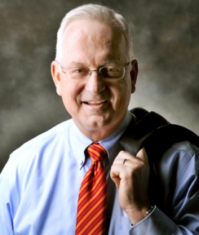

Find us on
Facebook
@ModRepUS
#PolicyOverPolitics

Paid for and authorized by the modern republic

Speaker Series on Modern Politics
Virginia Politics with Dr. Robert “Bob” Holsworth

I would like to attend the event as an:

Ticket Options:

___ Individual $55 (at cost) ___ Benefactor $1000

___ Sponsor $250 ___ Co-Host $2500

___ Patron $500 ___ Host $5000

I would like to purchase _____ (#) additional tickets

I cannot attend but I would like to donate $______

Please make checks payable to: The Modern Republic, P.O. Box 17102, Arlington, VA 22216

Contact Information of Ticket Purchaser
Full Name of Ticket Purchaser: Mrs. Jane Smith
Home Address: 1235 Stephens Lane, Fairfax, VA 12345
Home Phone (xxx) xxx-xxxx |  | Work Phone (xxx) xxx-xxxx
Cell Phone (xxx) xxx-xxxx |  | Make sure that you include at least one phone number or email address in case we need to obtain required information for the VA SBE finance report
E-Mail Address: j.smith@gmail.com

Names of Attendees
 | Full Name of Attendee (Mr. John Smith, Jr.) | E-Mail Address (optional)
1
2
3
4
5
6
7
8
9
10
To purchase tickets online through Eventbrite click the button to the right

